Macbeth in its Time
Macbeth was probably written some time between 1604 and 1606. It was first performed in 1606 in front of King James I at Hampton Court Palace.

King James was crowned in 1603, and in honour of his coronation, Shakespeare changed the name of his group of players (actors) from ‘The Chamberlain’s Men’ to ‘The King’s Men’.

Shakespeare knew how important it was for the King to like him and his work. The King had the power to stop a company of players from working if he so wished. As it happens, he liked Shakespeare’s company and gave them permission to perform in any appropriate building, including The Globe Theatre.

Of course, this meant that Shakespeare’s plays had to please King James.

King James I
King James I of England was also King James VI of Scotland and traced his ancestry back to Banquo and Fleance. He was familiar with the history of Macbeth, as it was part of his family’s story.

He was seen as a weak King because he was not physically strong, but he was a great scholar and wrote several books and poems during his lifetime.

He had a very strong view on the divine right of kings and a great fear of being assassinated.

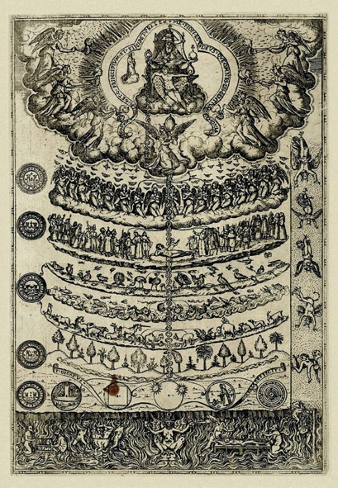

The Great Chain of Being
People at this time believed in the Great Chain of Being, whereby every person, animal and even plant or mineral was assigned a place in the world by God. It was wrong to aspire to a different place. God, of course, was at the top of the chain. Everyone else was in a strict order descending from God.

Along with this came the ‘divine right of kings’, which meant that the King was chosen and anointed by God; to go against the King, therefore, was to go against God.

James I and His Fears
James had every right to fear for his life; these were still violent times:
- His own father was killed and the family home was blown up with gunpowder.
- James came to the Scottish throne at 13 months old. There were several attempts on his life throughout his reign.
- James’ mother, Mary Queen of Scots, was Catholic and the Catholics hoped that, as King of England, James would bring Catholicism back. However, James had been brought up as a Presbyterian and so did nothing to change the Church in England at the time. James feared the revenge of the Catholics and believed they might plot against him.
- Owing to some odd coincidences when he married, James also had a great fear of witches and witchcraft.

Witches
Belief in witches at the time of King James was widespread, though not universal. When Queen Elizabeth I ruled England (before King James I), witchcraft was kept low key and Elizabeth did not allow the hysterical persecution of witches that took place in other countries.

In Denmark, it was a different story. A new theory of witchcraft had developed – that witches were agents of the Devil. This was the first time that witches had been connected to religion in this way.

It was also believed that no witch acted alone – so if you found one, there must be more.
Witch hunts became common in Denmark, with neighbour accusing neighbour and the ‘guilty’ burned at the stake.

Witches and James’ Wife
There is little evidence to show that James had any interest in witchcraft until he married.

In 1589, James married Anne of Denmark – by proxy, which means he wasn’t there and used another man to represent him! When Anne set off to meet her husband by ship, a great storm blew up and the ship had to take shelter on Norway’s coast.

James decided to set sail himself and meet his bride, but his ship too was stopped by foul weather and storms. When the couple finally met and set off for Scotland, yet another bout of stormy weather made the crossing difficult.

James and his wife believed that witches were casting spells to try to keep Anne out of Scotland. James was aware that witches were being hunted and burned in Denmark and he began to believe in these ideas himself.

Witch Trials
James’ interest in witches didn’t end there. He actually became involved in a witch trial in 1590 in North Berwick and was present at the interrogations and torture of the accused. He became convinced that these were the ‘witches’ who had tried to sink the ships when he and his bride were trying to meet.

Around 100 people were arrested and accused of trying to kill the King with black magic. Seventy were convicted, and although there are no records to say what happened to them, the usual punishment for witchcraft in Scotland at the time was burning at the stake.

Even so, witch mania did not take off in the same way in England. There were some trials, for example at Pendle in Lancashire where, in 1612, we people were arrested for being witches. The were charged with the murder of 10 people. In this case, however, the guilty were hanged as English law did not permit the burning of witches.

Daemonologie
James wrote a book about witchcraft in 1597 – it was called Daemonologie and considered magic, sorcery, fairies, werewolves, ghosts and the:
'fearefull aboundinge at this time in this countrie, of these detestable slaves of the Devill, the Witches or enchanters'.

James describes how witches can make demons appear to help them commit foul deeds. James is also clear that most witches are women:
‘What can be the cause that there are twentie women given to that craft, where ther is one man?’
‘The reason is easie, for as that sexe is frailer then man is, so is it easier to be intrapped in these grosse snares of the Devill, as was over well proved to be true, by the Serpents deceiving of Eva at the beginning, which makes him the homelier with that sexe sinsine.‘

Political Situation
James was not a well liked King to be begin with, but in 1605, a very sinister plot was hatched. Guy Fawkes and his fellow Catholics decided to use gunpowder to blow up the House of Lords, the King and most of the English nobility at the state opening of Parliament in November 1605. Fawkes was discovered, with the gunpowder, in a cellar and put in the Tower of London to be interrogated and tortured. He was executed on January 31 1606, as were the other conspirators.

King James declared the 5th November to be a day of celebration for his deliverance – and we still celebrate it today!

The memory and the shock of how near he came to death would be very fresh in the King’s mind when he watched the play Macbeth in 1606.

