Is Macbeth a Tragic Hero?

- A tragedy is the story of a great person with one fatal flaw which leads to his downfall. Macbeth had everything he needed in life. He was a hero, popular with the king, given new honours after being successful in battle. Then the witches put an evil ambition into his mind.

- Shakespeare's Macbeth is a tragic hero because he was not controlled by the witches, but made his own decisions with regards to the killings of Duncan, Banquo and the Macduff family.

- Macbeth may be seen as tragic hero because, although his rise to the throne is already predestined or predicted, he makes his own decisions in order to achieve those prophecies. The witches reveal Macbeth will become king, and of course this happens. However, Macbeth is the one who comes up with the idea of murdering the king in order to become king himself, this is NEVER suggested by the witches themselves. Macbeth himself admits there are lots of reasons to protect Duncan and only one to actually kill him: ambition.

- For some, Macbeth is no hero at all. Therefore he cannot be a tragic hero, although he begins the play as a celebrated warrior and loyal servant to Duncan.

It could be argued that Macbeth is a type of allegory

Lady Macbeth and Macbeth are representations of evil and corrupted goodness. They rejected goodness for the sake of their own ambitions.

Banquo, Duncan, Malcolm and Macduff are fundamentally good people – they fight for justice and fairness. Banquo is slaughtered because of Macbeth’s paranoid, but Malcolm and Macduff are victorious by the end of the play.

The rightful heir to the throne regains power at the play’s conclusion.
Therefore the play works quite well as an allegory for the struggle between good and evil.

Additionally, it pushes the notion of the ‘divine right of kings’ to the fore – a concept that was at the heart of King James’ philosophy on the monarchy.

Does Macbeth contain tragic waste?

The good being destroyed along with the bad at the resolution of the play. This particular element is more applicable to a play like Hamlet where most of the major characters are killed within the last scene of the play. However, in Macbeth we do see Duncan, Lady Macbeth, Banquo, Lady Macduff and Macbeth lose their lives before the end, yet some good characters triumph: Macduff and Malcolm.
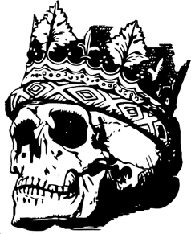

Does Macbeth contain external and internal conflict?

External conflict: Macbeth has to defeat Malcolm’s army after it becomes apparent Macbeth killed Malcolm’s father to get the throne.

Internal conflict: Macbeth is conflicted by how he should deal with events after he has killed Duncan. Eventually he decides not to think about what he should do but simply do whatever he thinks must be done. Additionally, Macbeth is conflicted over whether to kill Duncan in the first place or not.

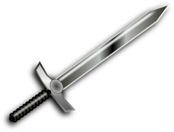

Does Macbeth contain catharsis?

This is an emotional release for one of the characters. Whilst we know what the main characters think, Macbeth isolates himself from his wife and everyone else, so this element is not necessarily applicable to Macbeth.

Does Macbeth contain the supernatural?

Magic, witchcraft, ghosts, and so on. Plenty of these in this play!

Does Macbeth contain a lack of poetic justice?

There is a sense of justice in this play, in that Malcolm becomes king as he should have been after his father died. However, the loose end of Fleance is left unresolved by the end.

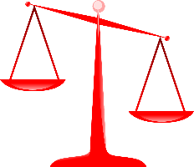

Does Macbeth contain comic relief?

The Porter Scene in Act 2 Scene 3 is a great example of comic relief, where despite the audience witnessing deception and murder we are still treated to jokes about drinking and the effects of alcohol.

